About FXWEBKIT:

FXWEBKIT is a complete solution for manage FOREX users and their trades , analysis and manage connecting to MT server .

There are three types of users can use this software admins, clients with their MT users and public persons, each one of them has his own area to manage his system through it those three areas are admin area, Clients area with agent area and pubic website.  
  
  
FXWEBKIT users types:

1. Admins :

the admin is who control the entire FXWEBKIT software ,the admin can control , add users al users like clients , agents and MT users .

Admin can login to the admin area and configure software settings.

The public website can be edited and change through admin CMS tools.

All MT server requests and configuration controlled from admin area.

1. Clients (FXWEBKIT) :

Clients are the software users whose enter the clients area where they can control, edit and add their MT users also they can be agents and get commission through their users whose register through them.  
There is two type of Clients :

1. Ordinary User: the user who register through the software directly or the admin add them.
2. Agent User: the agent is a client but he agree on agents agreements and the admin assign plans to him so he can invite users to register and trade then he get commission depend on the plan .
3. MT users: the users on MT server whose trade and get orders and can get to trade window and trade platforms.
4. Public person: anyone how get in public website which created by admin CMS.

FXWEBKIT Areas:

In FXWEBKIT there are three major areas each one for some type of users those areas :

1. Admin area : this area specialize for system admins users to control the whole system .

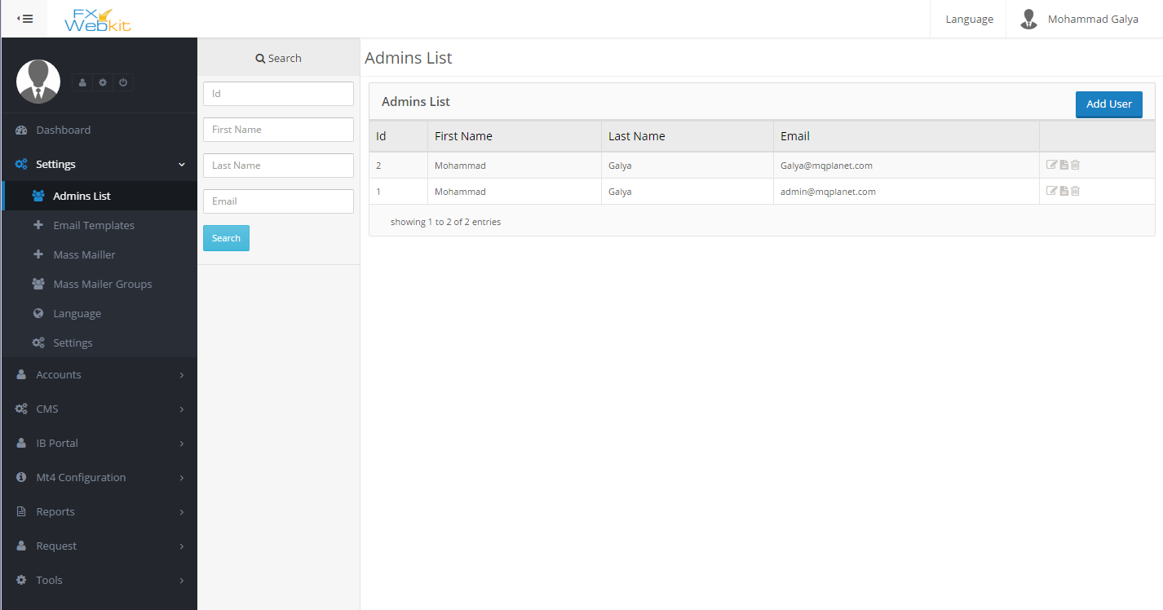

1. Client area: this area specialize for clients users to control their trades and MT users and their agent area .

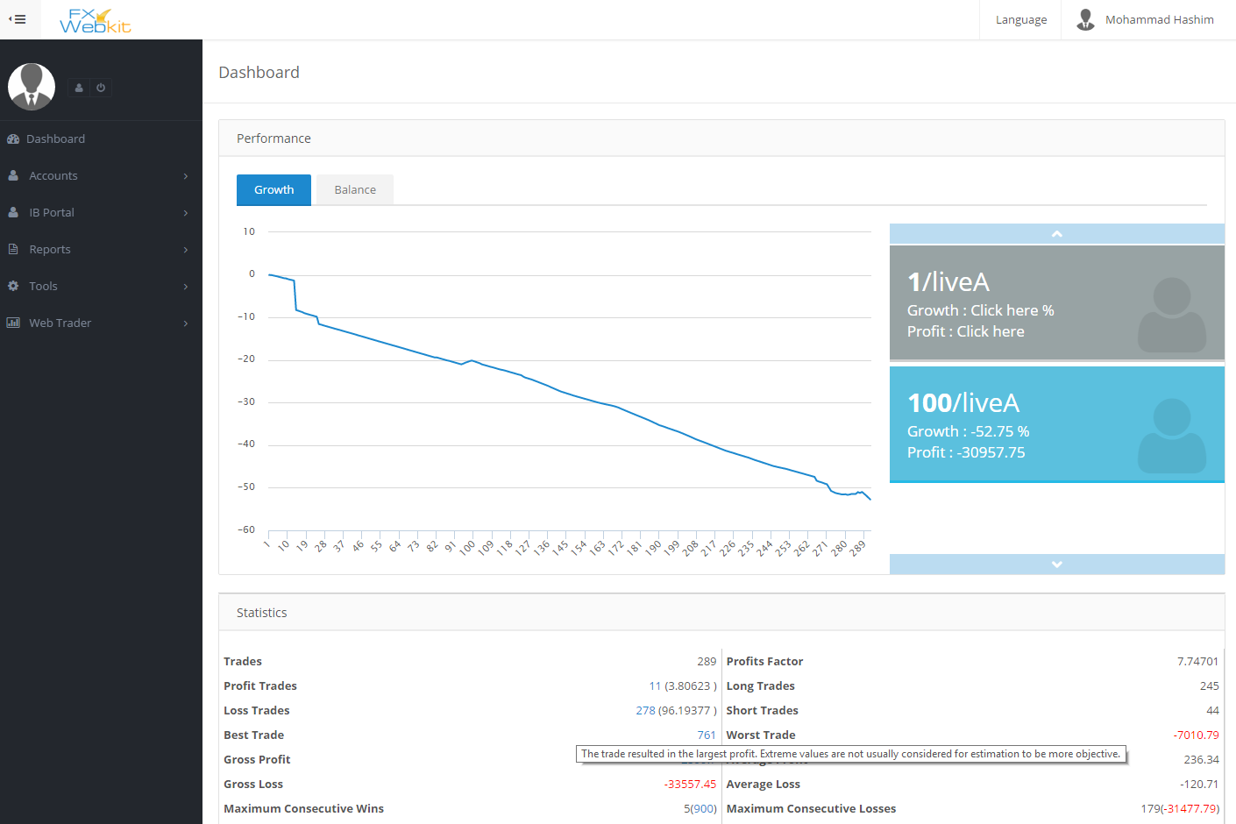

1. Public area: it’s the public website available for any one and it’s controlled through admin CMS tools.

